

**Merry Christmas & Happy New Year!! ☺**

**From: Ninang Lhen**

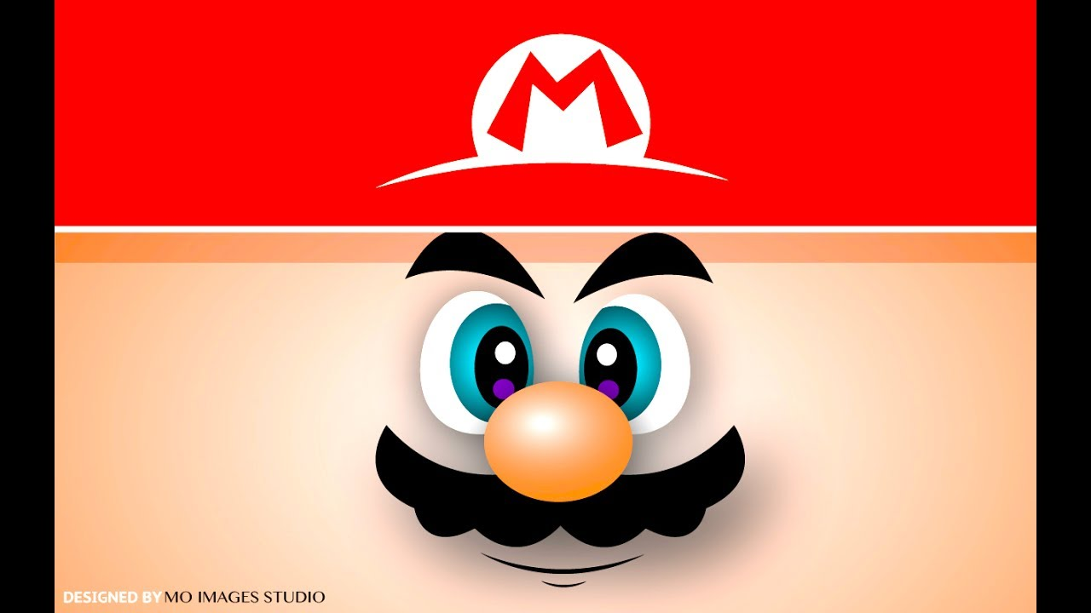

**Merry Christmas & Happy New Year!! ☺**

**From: Ninang Lhen**

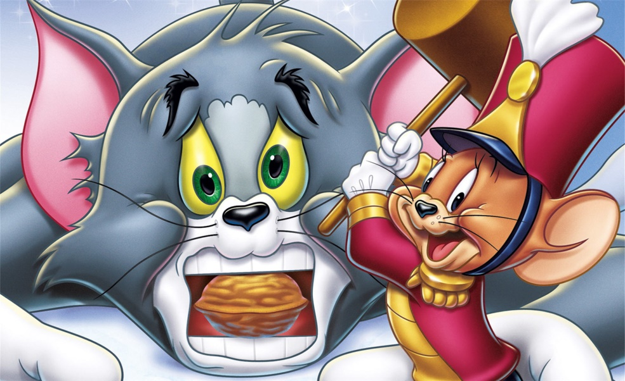

**Merry Christmas & Happy New Year!! ☺**

**From: Ninang Lhen**



**Merry Christmas & Happy New Year!! ☺**

**From: Tito John & Tita Lhen**



**Merry Christmas & Happy New Year!! ☺**

**From: Ninang Lhen**